Employee Management System (EMS)
CS3009 – Software Engineering

1. Introduction
The Employee Management System (EMS) is a Java-based system designed to automate and manage employee-related operations efficiently. In Sprint 1, core functionalities such as authentication, role-based access control, and employee management were implemented.
In Sprint 2, the system was extended by introducing leave management, attendance tracking, and employee search functionalities, along with completing leftover Sprint 1 modules. These enhancements significantly improved system usability and operational efficiency.
The system continues to follow the Scrum methodology, enabling iterative development and continuous stakeholder feedback.

2. Project Vision
The vision of EMS remains to provide a secure, centralized, and scalable system for managing employees. Based on Sprint 1 feedback, the vision is refined to include:
- Improved workforce tracking through attendance monitoring
- Better resource planning via leave management
- Faster data retrieval using search functionality
- Enhanced decision-making through structured employee data

3. Intended Use of the System
3.1 Stakeholders (Unchanged)
- Administrator
- HR Manager
- Manager
- Employee
- Finance Department
- Top Management
- IT Support

3.2 Updated Stakeholder Needs
HR Manager
- Search employees efficiently
- Track employee attendance
- Monitor leave records
Manager
- Approve/reject leave requests
- Monitor employee availability
Employee
- Apply for leave
- Mark daily attendance
(Other stakeholder needs remain same as Deliverable 1)

4. Features / Functionality
Completed in Sprint 1:
- User Authentication
- Role-Based Access Control
- Add Employee
- Update Employee
- Deactivate Employee
Implemented in Sprint 2:
- Apply for Leave
- Approve/Reject Leave
- Attendance Tracking System
- Employee Search Function
Improvement Explanation:
Sprint 2 enhanced the system by:
- Adding workflow automation (leave approval process)
- Introducing real-time tracking (attendance)
- Improving data accessibility (search functionality)

5. User Stories (Sprint 2)
US7 – Apply for Leave
As an employee
I want to submit leave requests
So that I can request time off

US8 – Approve/Reject Leave
As a manager
I want to approve or reject leave requests
So that workforce availability is managed

US9 – Mark Daily Attendance
As an employee
I want to mark check-in/check-out
So that working hours are recorded

US11 – Search Employee
As an HR manager
I want to search employees
So that I can quickly locate records

(Also completed from Sprint 1 leftovers)
- Role-Based Access Control
- Update Employee Information

7. Iteration 2 Implementation Screenshots
Leave Application Screen
Employee with ID: EMP001 is selecting the leave type and no of days for leave request.
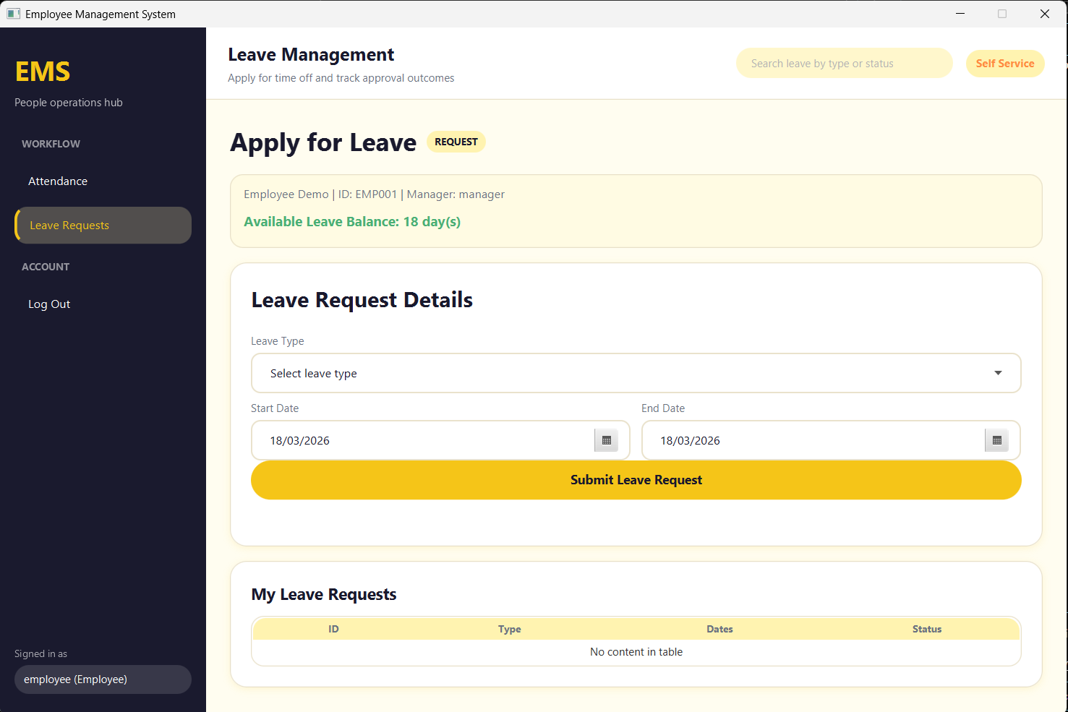

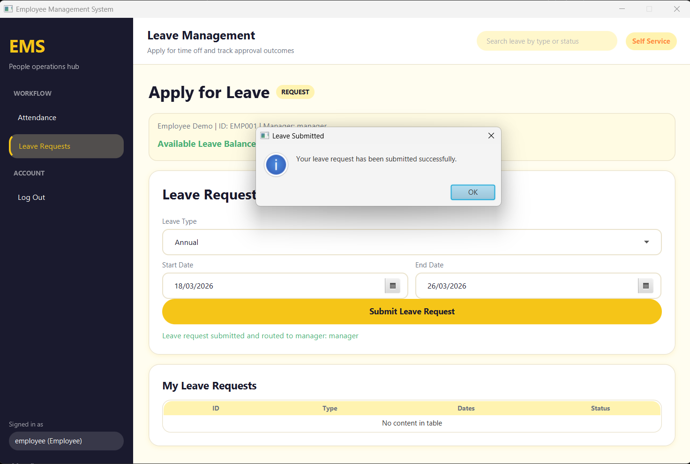
Annual Leave Application for 9 days of Employee with ID: EMP001 submitted successfully.

Leave Approval Screen
Admin viewing all the pending leave request for approval/rejection.
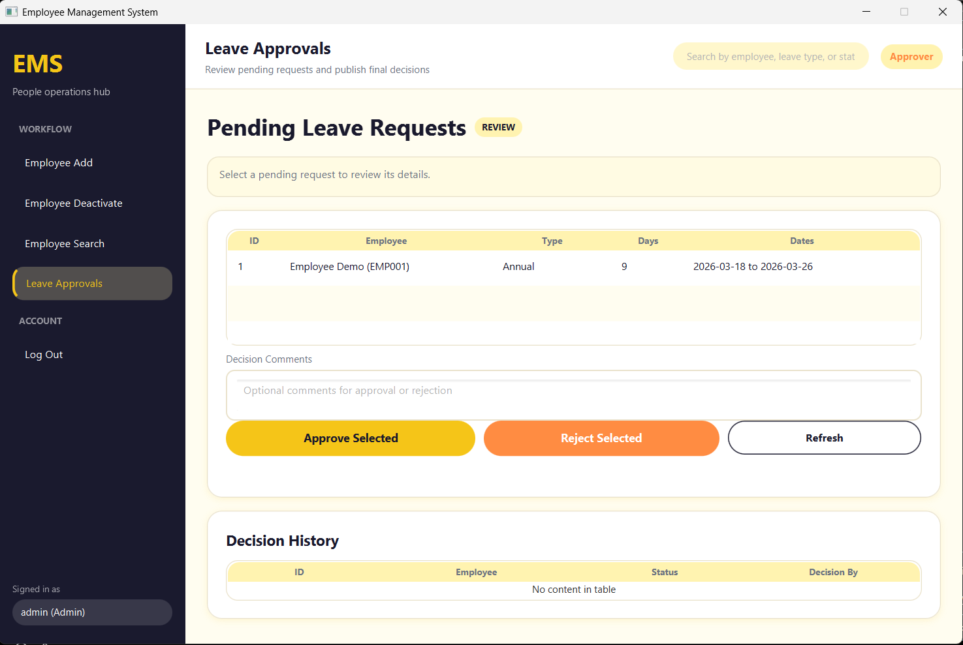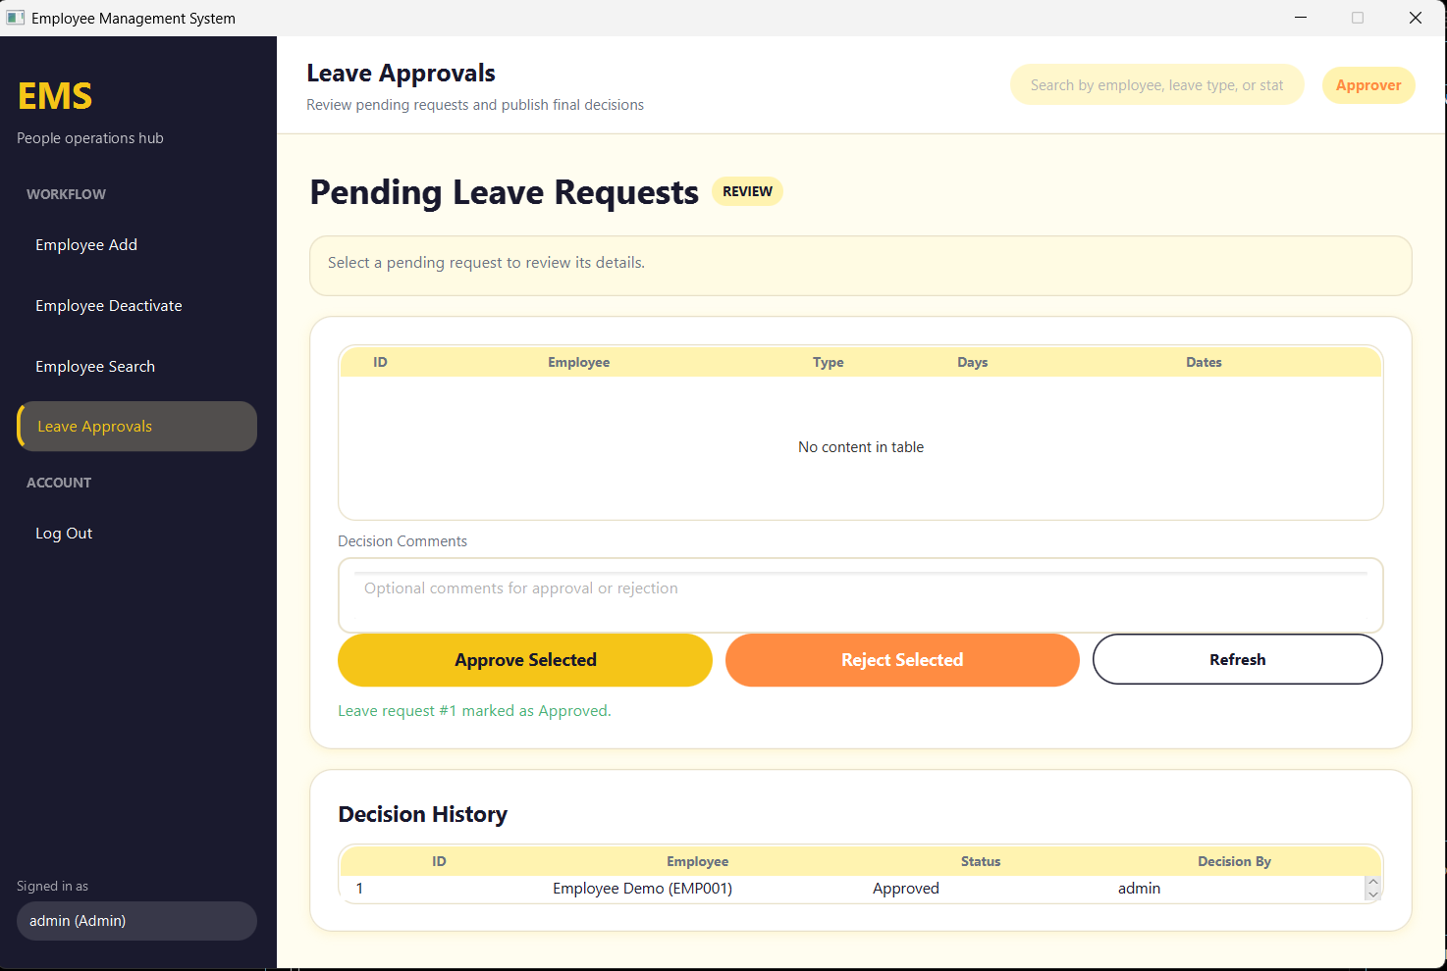
Admin selected the pending request of EMP001 and approved it and the decision history is being shown.
Attendance Marking Screen
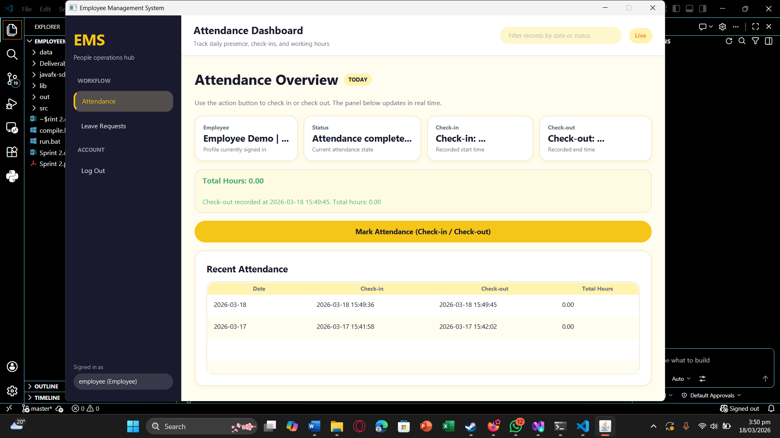
Employee clicks on “Mark Attendance (Check-in / Check-out)” button and the check-in time is recorded and on the second click Check-out time is recorded. No. of hours spent in the office are also shown.
Leave Rejection
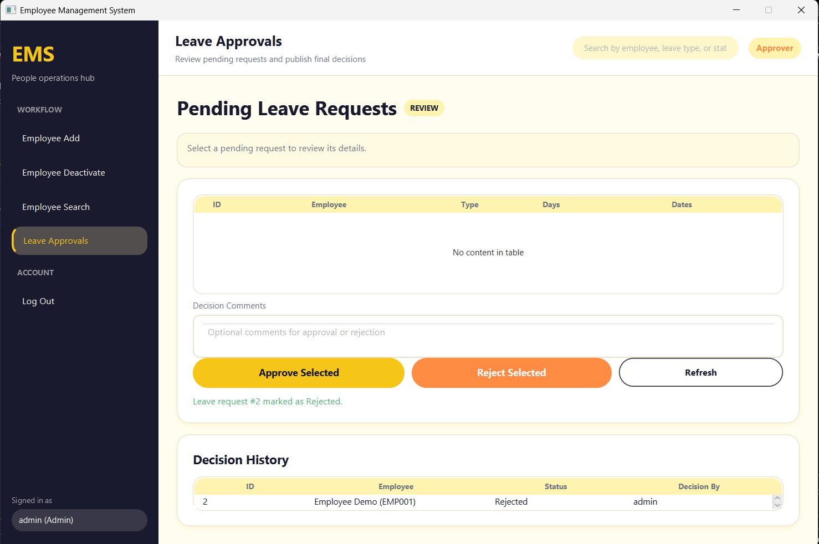
Admin selected EMP001 request and rejected and the decision is being shown in Decision History Table.

Employee Search Screen
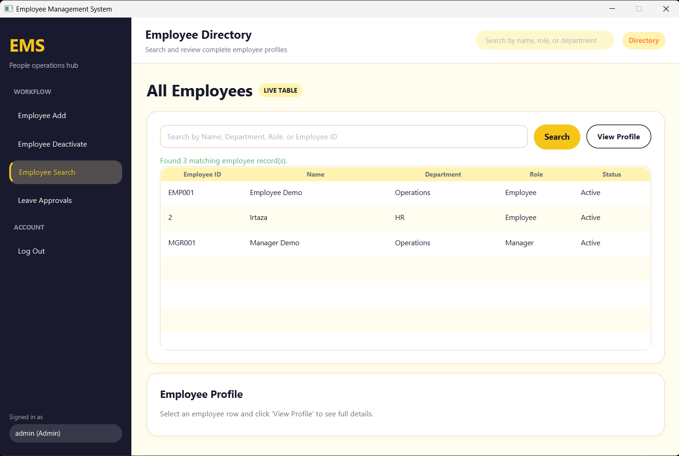
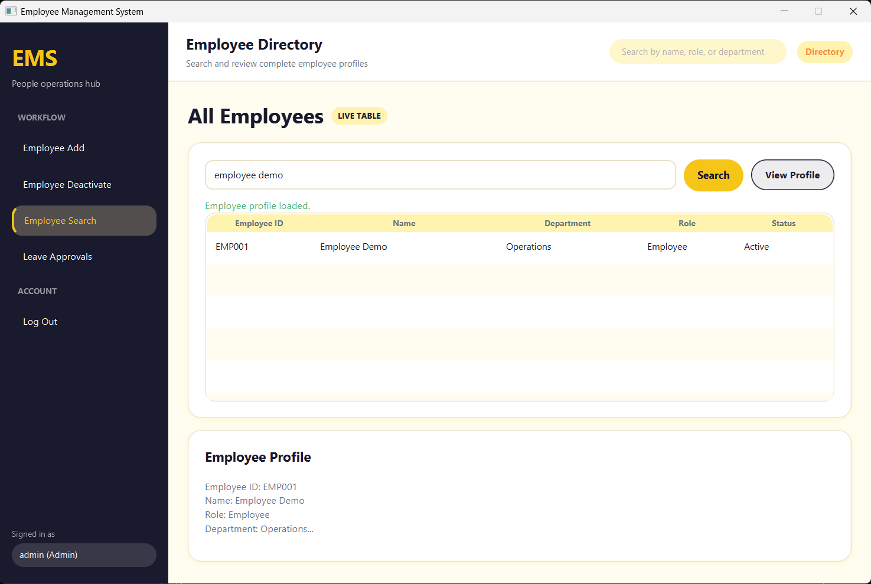
In Employee Search Tab, admin can see the list of all employees and search the employee by Name, Department, Role, or Employee ID.
On Searching, the results are shown and by clicking “View Profile”, profile is displayed at the bottom as well.

8. Work Division (Sprint 2)
Muhammad Faheem (Scrum Master and Developer)
- Managed sprint planning and defined Sprint 2 goals
- Created and maintained Sprint 2 backlog
- Designed workflow for Leave Management system
- Implemented:
  - Leave request submission logic
  - Leave approval/rejection logic
- Handled integration between:
  - Leave module and employee records
- Monitored sprint progress and resolved blockers
- Coordinated team meetings and ensured task completion

Irtaza Kazmi (Developer and Tester)
- Designed and implemented Attendance Tracking System:
  - Check-in/check-out functionality
  - Timestamp recording
  - Working hours calculation
- Developed Employee Search Module:
  - Search by name, ID, department
  - Filtering and result display logic
- Assisted in:
  - Backend database queries
  - Integration of attendance with payroll logic
- Performed debugging and optimization of backend logic

Humayun Bilal (UI Designer & Developer)
- Designed UI screens for:
  - Leave application form
  - Leave approval dashboard
  - Attendance interface
  - Employee search page
- Ensured:
  - User-friendly layout
  - Consistent UI design across modules
- Conducted testing for:
  - Leave workflows
  - Attendance marking
  - Search functionality
- Identified bugs and reported issues for fixes
- Assisted in final system integration and validation

Collaboration Tasks (Shared)
- Database schema updates for:
  - Leave records
  - Attendance logs
- Integration testing across modules
- Preparation of:
  - Trello board updates
  - Burn-down chart
  - Documentation

